**Social Survey System Setup**

1 Setup Java ( below 1.8 ):

* Goto “<http://www.oracle.com/technetwork/java/javase/downloads/java-archive-downloads-javase7-521261.html>”

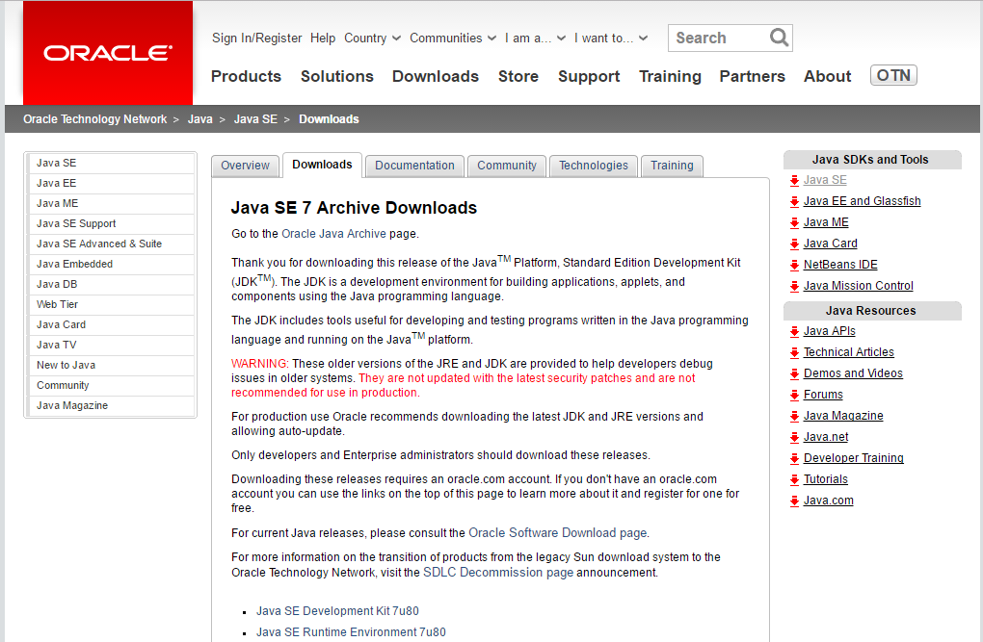

* Download the latest Java SE 7 SDK below ( 7u80 in the above picture ).
* Click on “accept the agreement” and download to the device.
* Run the setup file and install java in the system.

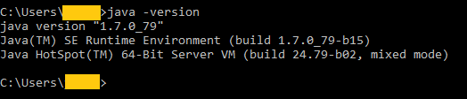

* Set JAVA_HOME, in System environment as installed java directory.
  + goto System Properties tab > environment Variables

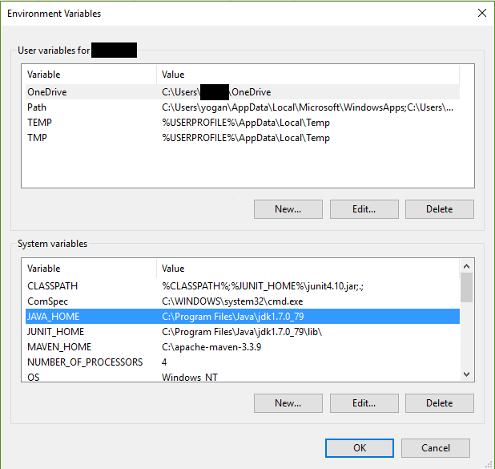

* + Add %JAVA_HOME%\bin to System Path.

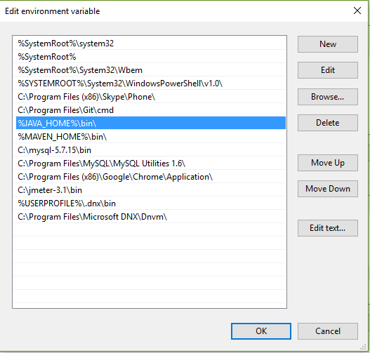

* Download the security policy for java with JCE ( Java Cryptography Extension **)**
  + Goto “<http://www.oracle.com/technetwork/java/javase/downloads/jce8-download-2133166.html>”
  + Click on “accept the agreement” and download to the device.

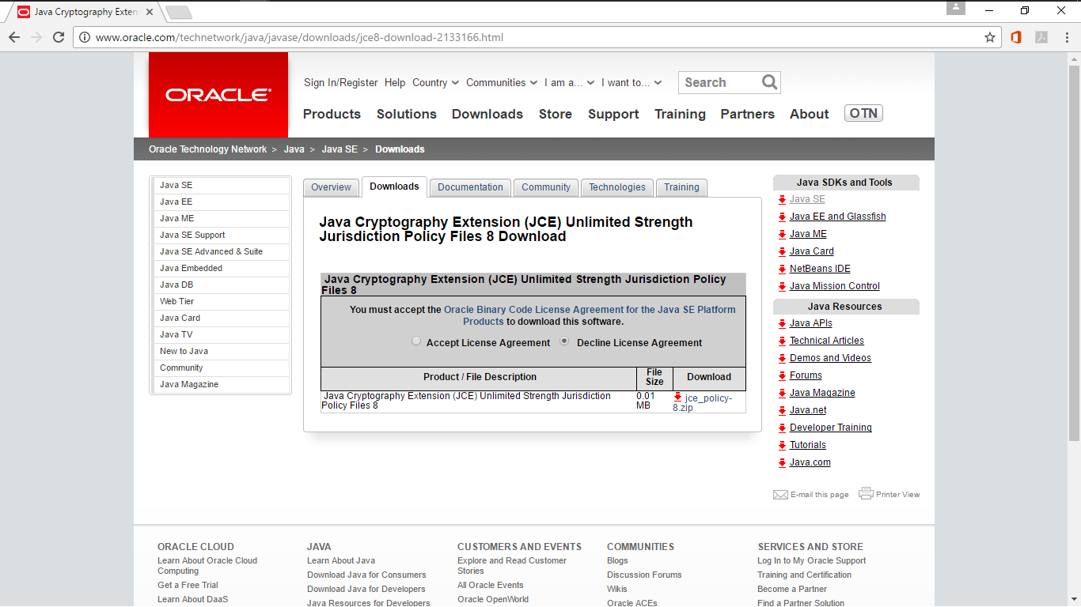

* Copy and Replace the contents of the downloaded Zip file to
  + “**< Installed JDK directory > \jre\lib\security”**

2 Setup Maven:

* Download and Install latest Version of Apache Maven.
  + goto “https://maven.apache.org/download.cgi”
  + download a suitable Binary Zip Archive

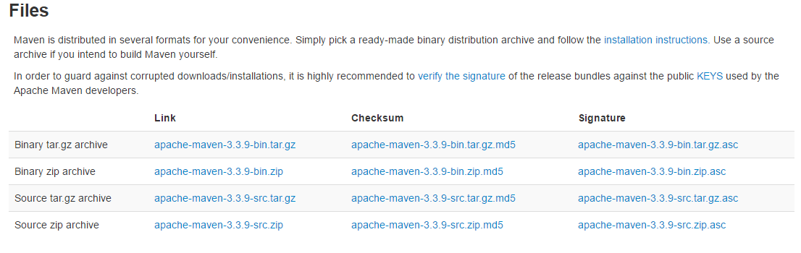

* Place the contents of the Zip File to “maven” folder in a suitable directory

( “C:\” or “/” )

* Set MAVEN_HOME in System environment as Installed Maven Directory.

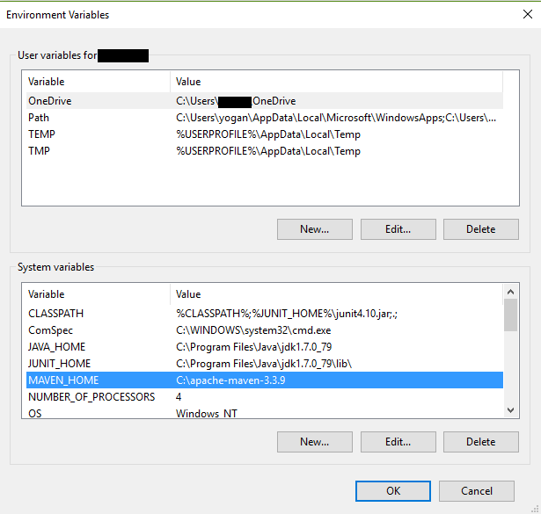

* Add %MAVEN_HOME%\bin to System Path.

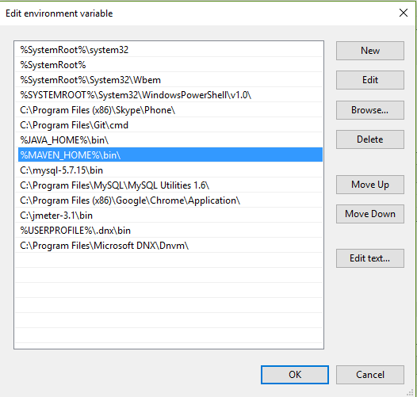

3 Setup Git:

* goto “https://www.sourcetreeapp.com”

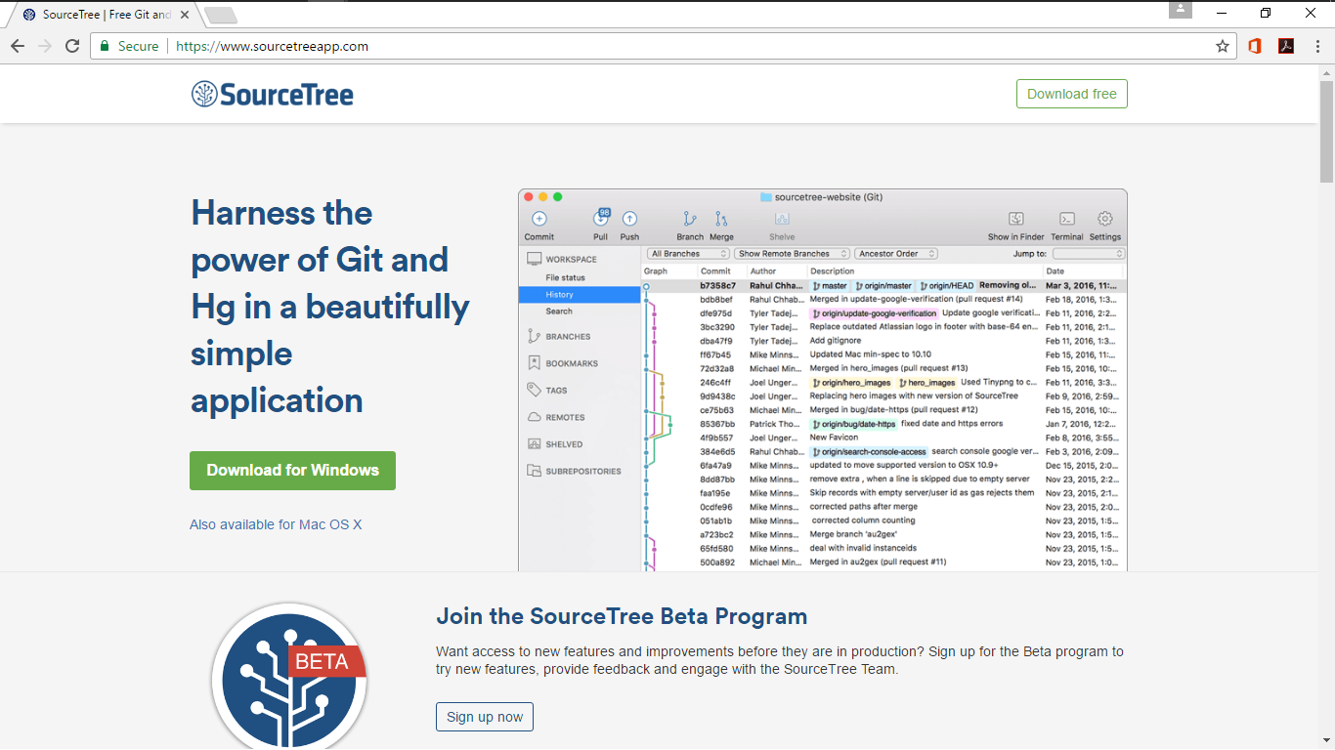

* Run and Install SourceTree with a google account.
* Upon getting access to social Survey on GitHub, follow these steps
  + Fork the Social survey repository to your github Account

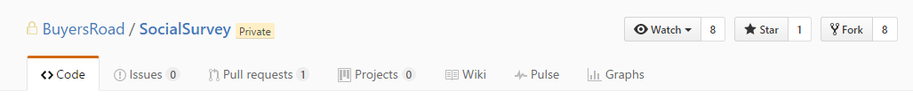

* + open Source Tree > store your github username and password.
  + Clone the Forked github repository
    - goto File > clone/new

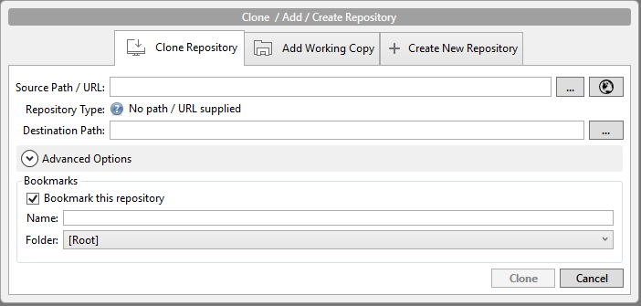

* + click the globe button and choose the forked repository.
  + goto Repositories > add Remote and add “upstream” with the Url of the original repository NOT the forked repository.
  + Do the same of forked repository named “origin” if not already present.
  + Source Tree should now show two remotes listed

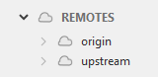

* + Expand upstream and checkout “devel” as new branch
    - right click and choose checkout “upstream/devel”

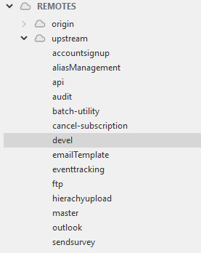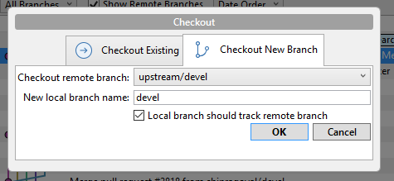

* + devel should now be in the working copy on hard drive.
* Points to Remember
  + after making changes to the code of a particular branch and before checking in the changes
    - Always “pull from upstream” for latest code
    - resolve any conflicts on the local machine
    - then check in the latest code with the local changes.
  + While checking in the “base” branch and the “forked” branch should always be the same, e.g
    - base: Master >>>forked: Master
    - base: Devel >>> forked: Devel

4 Setup MySQL and create ss_user database:

* goto “<https://dev.mysql.com/downloads/>” and download

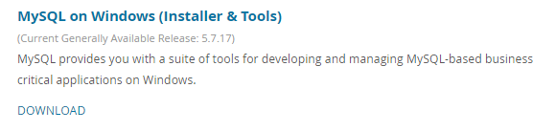



* Install Latest Mysql Server MySQL connector and MySQL Workbench
  + select the above packages and install them through MySQL installer.
* Configure the Username and Password for the Database as “root” and “root” respectively.

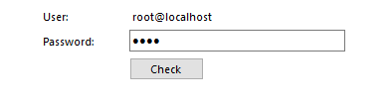

* products to be installed….

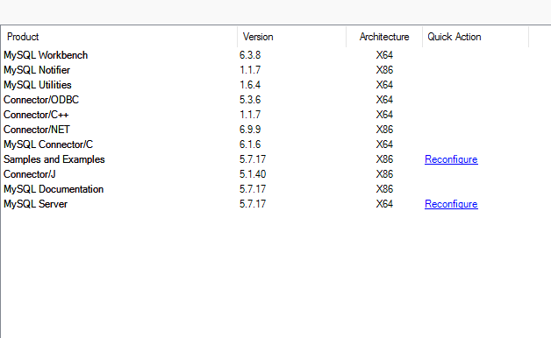

* MySQL instance should be Running on “localhost:3306”

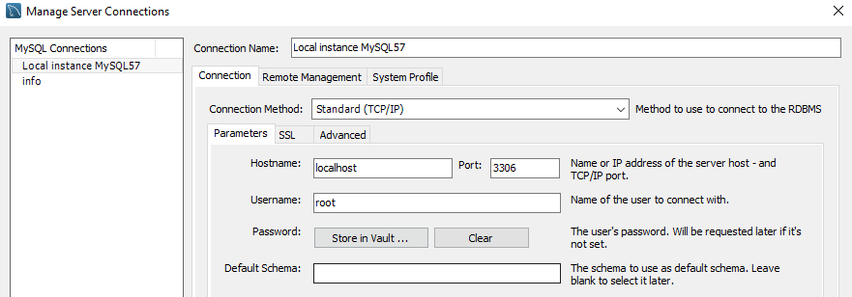

* Run the SQL scripts in “DBScripts” folder in Local Repository
  + this will create ss_user database and the necessary tables on the local machine.

5 Setup MongoDB( below 2.6 or 2.6 ):

* goto “<https://www.mongodb.com/download-center#community>” and download the mongo server.

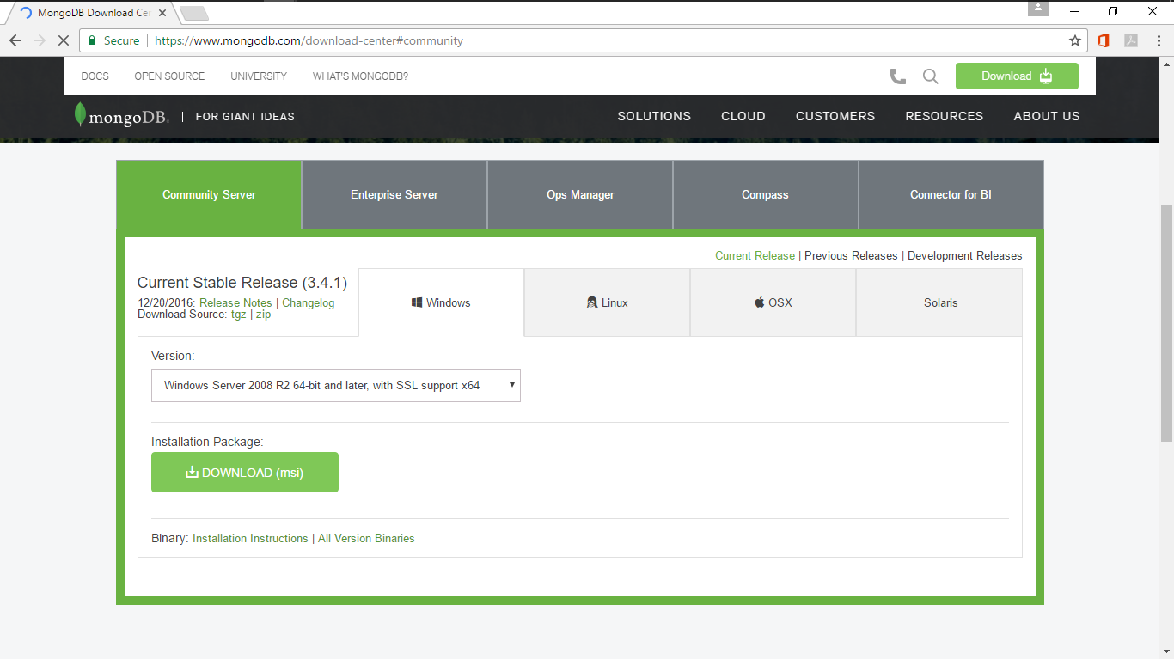

* Install MongoDB ( 2.6 ) server and Client ( RoboMongo )
* create a Directory for database to reside
* preferably “**<Location of Social Survey>\Docs\**”
* open command line and enter the following
* “**start mongod.exe --dbpath <location of the database>**”
* if you have a zip file then
  + Go to the path where Mongodb is copied and into .\bin Directory
  + then open command line in that directory and execute the above command.
* Mongod should be running on port 27017

6 Setup Eclipse:

* download and install Eclipse IDE with Spring,Git, and maven support.
  + goto “https://eclipse.org/downloads/”

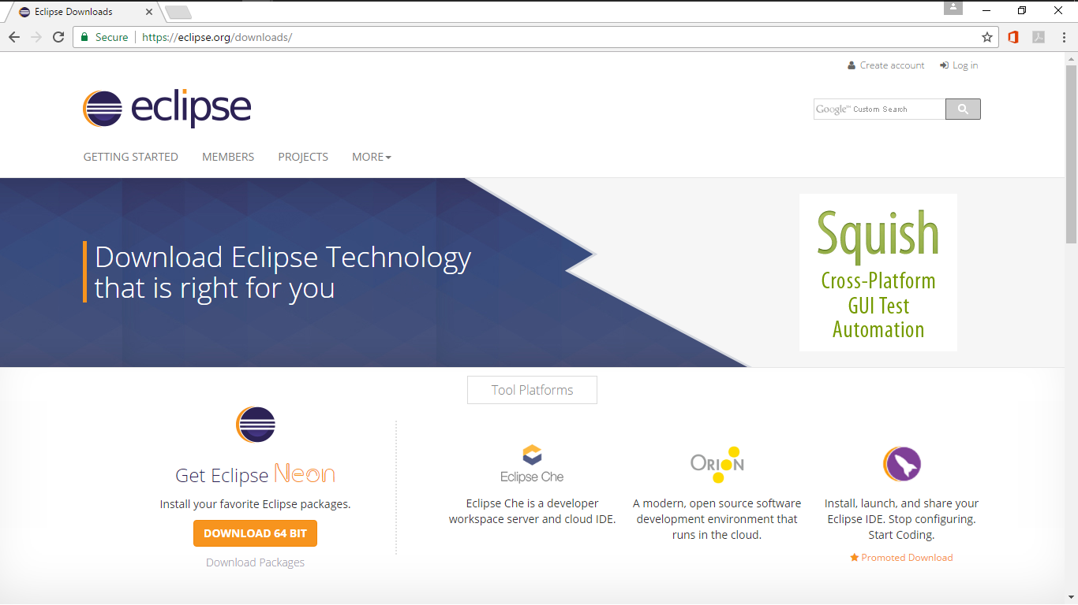

* For the First Run, create a workspace in any other directory( /Users/<name>/ )

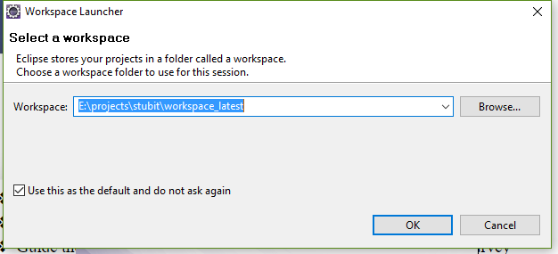

* Navigate to File > Import > Maven > Existing Maven Projects.
* Guide the “Browse file” Dialog Box to “Source” Folder in “Social Survey” present in Local repository as the Root Directory.
* check all Three CheckBoxes
  + SSApi/pom.xml
  + SSCore/pom.xml
  + SSWeb/pom.xml
* after the import is finished, three projects should be visible.

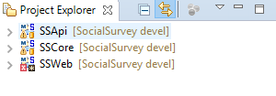

* after all the Three Projects are Loaded, Navigate to window > preferences and add formatters for Html, Java and Jsp present in “Formatters” folder.

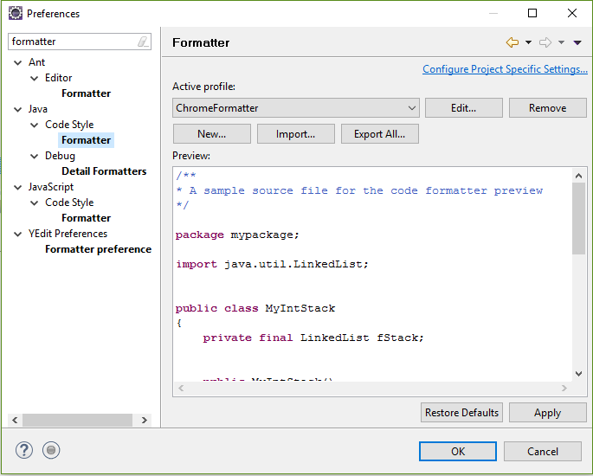

* enable remote debugging in eclipse.
  + In eclipse, navigate to Run > debug configurations
  + create a new remote java application and name it.

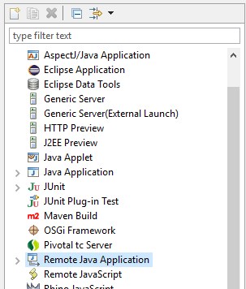

* + and enter the below details.

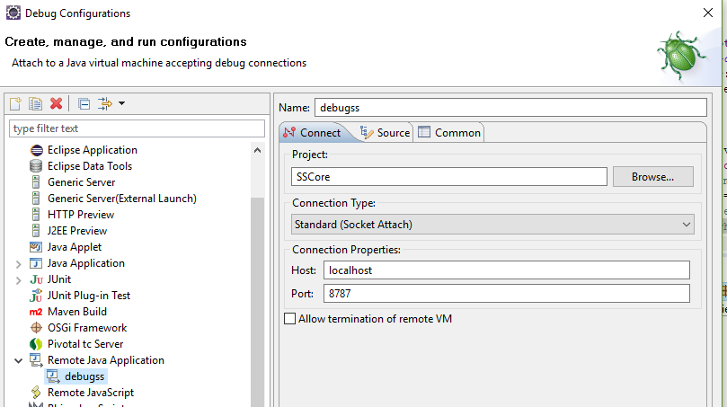

* + goto source tab and and include ( “SSCore” can be skipped )
    - SSApi
    - SSCore
    - SSWeb

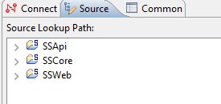

* click on “Apply” and close the table
* the remote application can be debugged by clicking on  or by navigating to Run > debug > **<name of the remote java application>**

7 Setup JBoss:

* Download and Install Jboss AS.
  + goto “<http://jbossas.jboss.org/downloads/>”

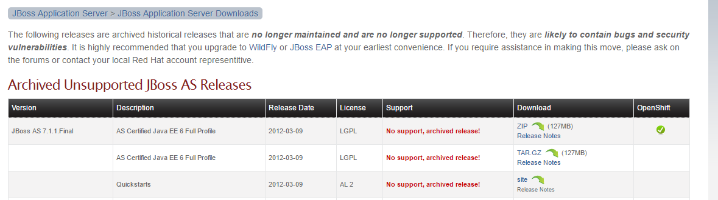

* After installing jboss
  + goto Standalone > Configuration
  + open standalone.xml
  + add <substem> like Mysql, hibernate etc

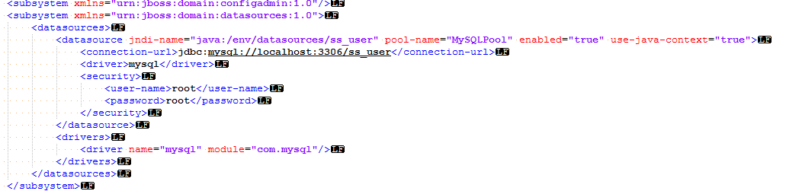

* + set the port default to 8080
  + set “enable-welcome-root” to false.

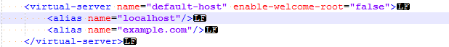

* + set deployment-timeout="500000" for the default “deployment-scanner” tag ( or copy and paste standalone.xml from other device).
* goto to bin folder, open “standalone.conf” CONF file
  + add **JAVA_OPTS="-Xdebug -Xnoagent -Xrunjdwp:transport=dt_socket,address=8787,server=y,suspend=n $JAVA_OPTS"**



* + The above line is added for debugging for eclipse to access the social survey application at port 8787.
  + Do the above changes in standalone.conf.bat also

8 Setup Solr:

* install Apache Solr and add Schemas for “SSSolr” Folder to installed solr Directory
* click on run.bat to run Solr server
* Or the entire solr folder can be imported from another machine.

9 Build Social survey Application:

* goto <Social Survey>\Source and open command line/terminal
* type **“mvn clean compile package -Pdev”**

10 Move packaged war files to Jboss:

* copy and paste .war files in “target” directories of “SSApi” and “SSWeb” folders in “Source” folder to “**<Location of Jboss>\standalone\deployments\**”.

11 Start Social survey on System ( localhost ):

* navigate to “**<Location of Jboss>\bin”.**
* Run standalone.bat

12 Start Social survey Web Application:

* open the installed browser and navigate to “**localhost:8080**”

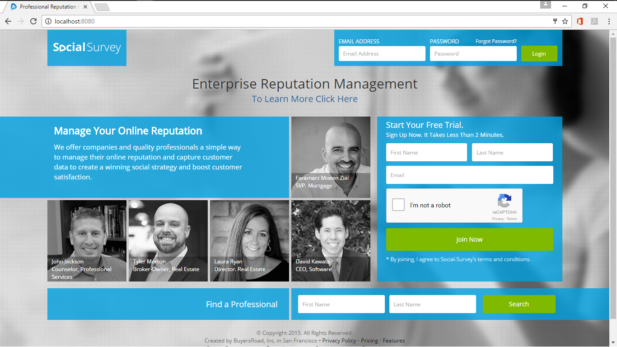

Optional ( Receiving Feeds from Encompass CRM ):

* In Order to run C# application for encompass CRM, Install visual Studio and import the solution ( .sln ) from “encompass” folder
  + goto “https://www.visualstudio.com/downloads/”

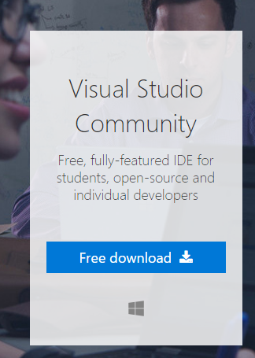

* Install dependencies from Nuget manager ( right click on the .sln file and find to Nuget and update Packages and assembly references)

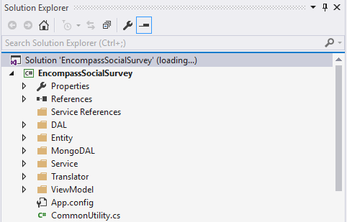

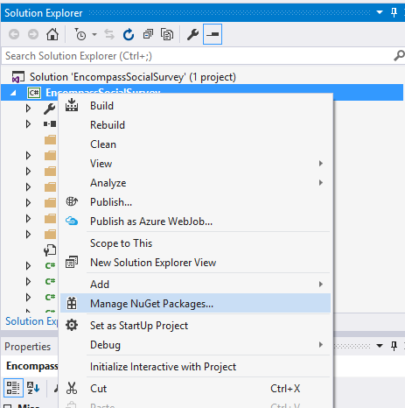

* build the solution to get “EncompassSocialSurvey.exe” ( build option visible in the above picture ).